THERMAL VACUUM TEST REPORT

The test article was only turned on when the target temperature of the internals was achieved. (40 °C for hot condition and -15 °C for cold condition).

The PeTT surface plate temperature variation through the thermal cycles was as following:

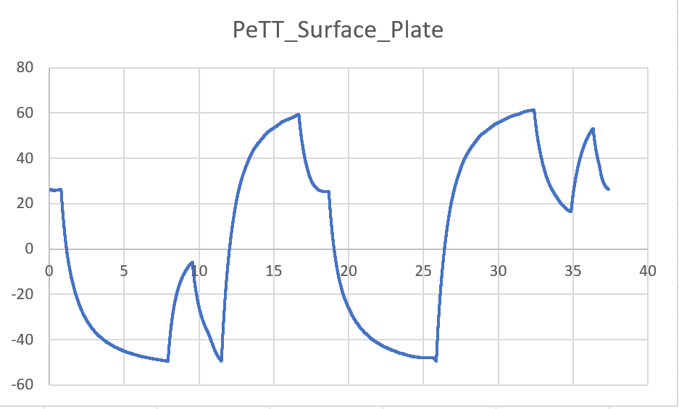

At the end of the 1st cold ramp, the “cooling” was turned off because all the internal boards were below -20 °C (they needed to be just -15°C), the cooling was turned on again after te internals got to -15°C. During the hot ramps, the heater of the chamber was turned off when all the internal boards reached +40°C.

In order to try to get a temperature stabilization around -20°C for the internal boards, the water chiller was injecting water at 20°C (normally it injects water at 0 °C).

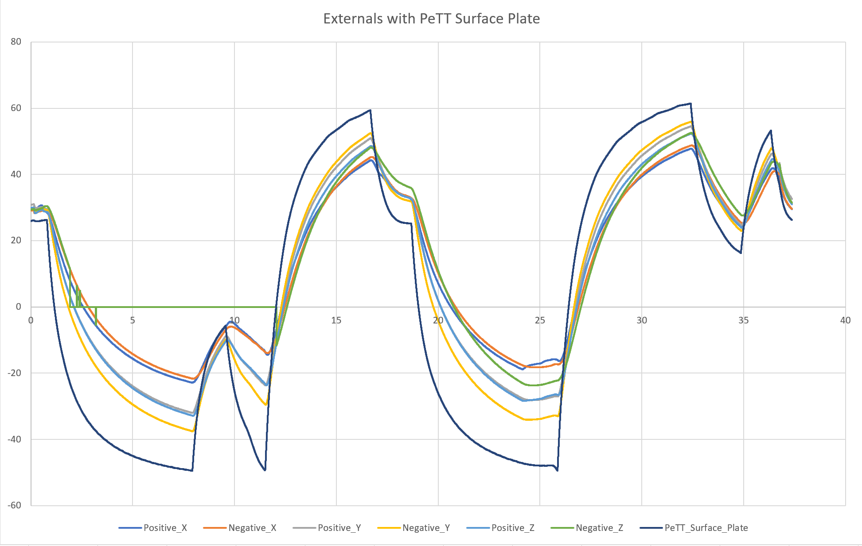

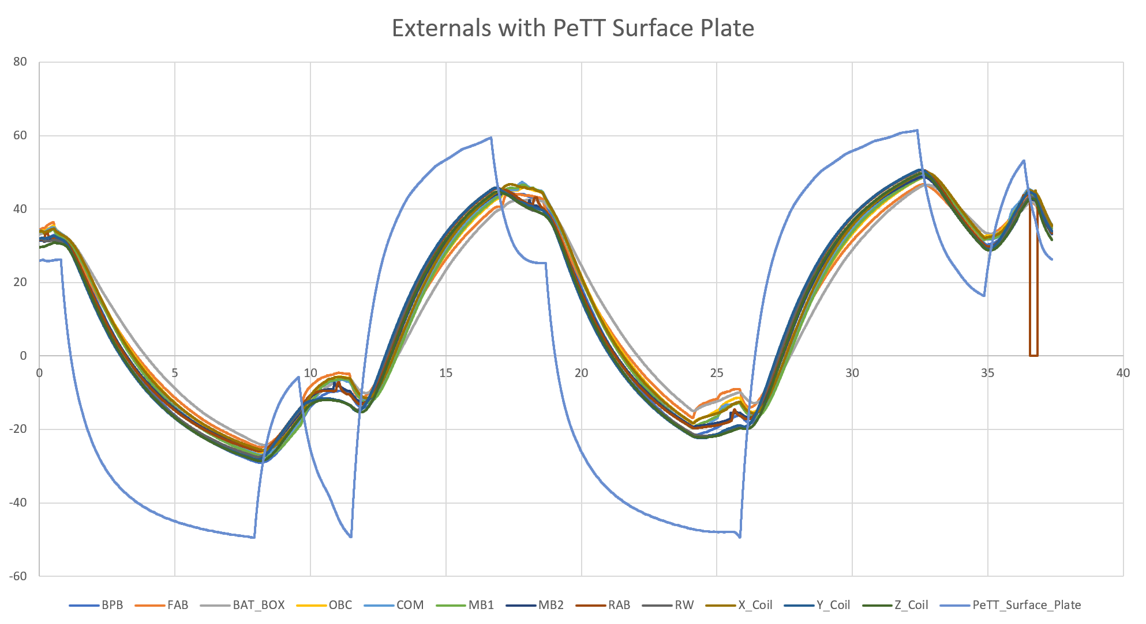

Extreme temperatures reached (°C):

|  |  |  |  |  |  |  |
| --- | --- | --- | --- | --- | --- | --- |
|  | Positive_X | Negative_X | Positive_Y | Negative_Y | Positive_Z | Negative_Z |
| MAX | 47.791919 | 48.784476 | 54.550399 | 55.945504 | 52.358557 | 52.540463 |
| MIN | -22.861582 | -21.659484 | -32.021384 | -37.55868 | -32.846694 | -23.710012 |

|  |  |  |  |  |  |  |
| --- | --- | --- | --- | --- | --- | --- |
|  | BPB | FAB | Bat Box | OBC | COM | MB1 |
| MAX | 49.202293 | 46.726229 | 46.569627 | 48.711146 | 49.599171 | 48.723006 |
| MIN | -29.038432 | -24.823866 | -24.295579 | -26.223783 | -26.925583 | -27.348549 |

|  |  |  |  |  |  |  |
| --- | --- | --- | --- | --- | --- | --- |
|  | MB2 | RAB | X_Coil | Y_Coil | Z_Coil | RW |
| MAX | 48.803944 | 50.605383 | 49.999126 | 50.74119 | 49.741268 | 50.563567 |
| MIN | -25.712244 | -25.904539 | -25.613333 | -28.208609 | -28.589519 | -27.544217 |